Match each diagram with its correct description. Diagrams will be used once.

Name _______________________________ Period ________

816 Elements, Compounds, Symbols and Formulas

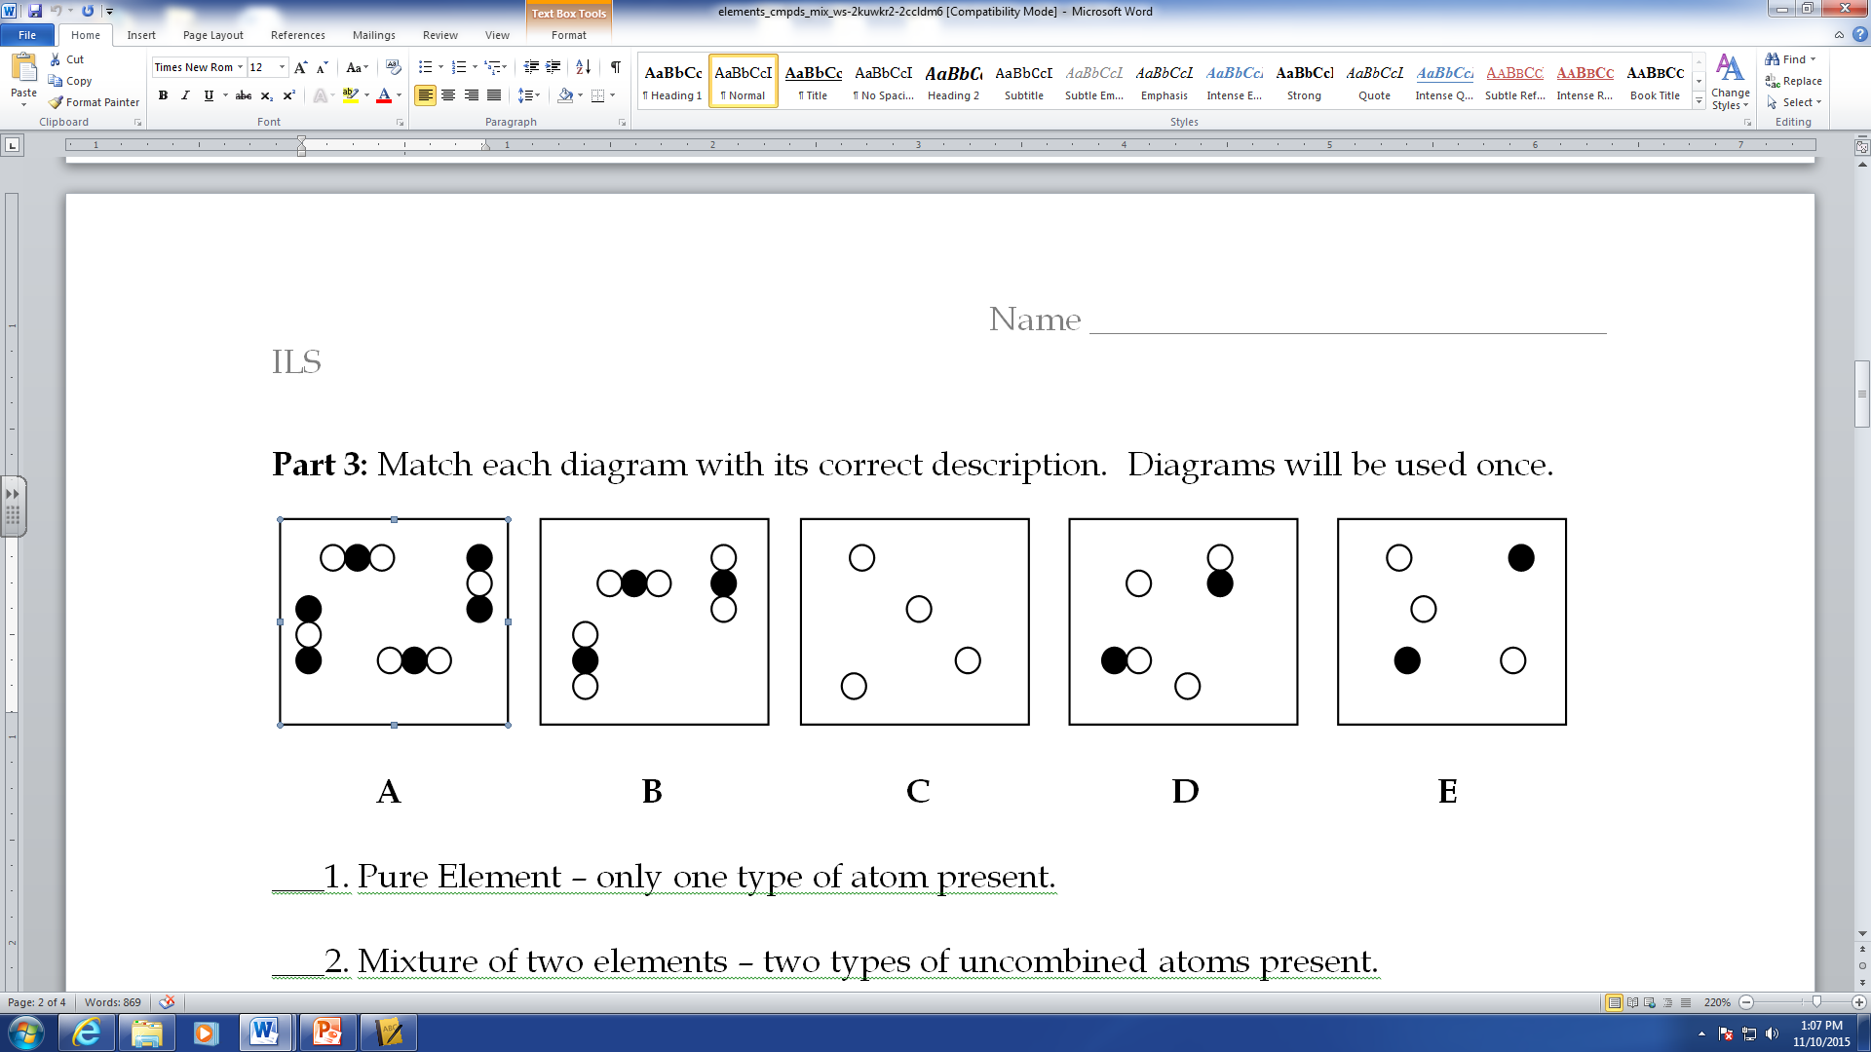

___1. Pure Element – only one type of atom present.

___2. Mixture of two elements – two types of uncombined atoms present.

___3. Pure compound – only one type of compound present.

___4. Mixture of two compounds – two types of compounds present.

___5. Mixture of a compound and an element.

Column A lists a substance. In Column B, list whether the substance is an element, a compound, or a mixture. In Column C, tell whether the mixtures are homogenous (solutions) or heterogeneous.

|  |  |  |
| --- | --- | --- |
| **Column A** | **Column B** | **Column C** |
| 1. Summer Sausage |  |  |
| 2. Steam |  |  |
| 3. Salt Water |  |  |
| 4. Pencil lead (Pb) |  |  |
| 5. Dirt |  |  |
| 6. Pepsi |  |  |
| 7. Silver (Ag) |  |  |
| 8. Toothpaste (Na2HPO4) |  |  |
| 9. A burrito |  |  |
| 10. Italian Dressing |  |  |
| 11. Chicken Soup |  |  |
| 12. Lemonade |  |  |

Read the following information on elements, compounds and mixtures. Fill in the blanks where necessary.

**Elements:**

* A pure substance containing only one kind of ____________.
* An element is always uniform all the way through (homogeneous).
* An element _____________ be separated into simpler materials (except during nuclear reactions).
* Over 100 existing elements are listed and classified on the ____________________.

**Compounds:**

* A pure substance containing two or more kinds of _______________.
* The atoms are _________________ combined in some way. Often times (but not always) they come together to form groups of atoms called molecules.
* A compound is always homogeneous (uniform).
* Compounds ___________________ be separated by physical means. Separating a compound requires a chemical reaction.
* The properties of a compound are usually different than the properties of the elements it contains.

**Mixtures:**

* Two or more ________________ or _________________ NOT chemically combined.
* No reaction between substances.
* Mixtures can be uniform (called ________________________) and are known as solutions.
* Mixtures can also be non-uniform (called ________________________).
* Mixtures can be separated into their components by chemical or physical means.
* The properties of a mixture are similar to the properties of its components.

**Part 2:** Classify each of the following as elements (E), compounds (C) or Mixtures (M). Write the letter X if it is none of these.

___Diamond (C) ___Sugar (C6H12O6) ___Milk ___Iron (Fe)

___Air ___Sulfuric Acid (H2SO4) ___Gasoline ___Electricity

___Krypton (K) ___Bismuth (Bi) ___Uranium (U) ___Popcorn

___Water (H2O) ___Alcohol (CH3OH) ___Pail of Garbage ___A dog

___Ammonia (NH3) ___Salt (NaCl) ___Energy ___Gold (Au)

___Wood ___Bronze ___Ink ___Pizza

___Dry Ice (CO2) ___Baking Soda (NaHCO3) ___Titanium (Ti) ___Concrete